 | Filing Reference : |  | GG/COMS/TS.2/1
 | Document Title : |  | Use-Case Realization Report (Analysis)  Change Cylinder Priority
 | Version : |  | 1.0
 | Prepared By : |  | Koh Ming Jin
 | Date Created : |  | Monday, Apr 29th, 2011
Approved By :
 |  | Tran Ba Tien |  | Date
 |  | Project Manager |  | 29th Apr 2011
©2011 [Hoang Kim joint stock Company].
The information contained in this document is the property of [Hoang Kim joint stock Company]. The contents must not be reproduced, wholly or in part, for purposes other than for which it has been supplied, without the prior permission of [Hoang Kim joint stock Company], or, if it has been furnished under contract to another party, as expressly authorised under that contract. [Hoang Kim joint stock Company] shall not be liable for any errors or omissions.

Revision History
Date | Version | Description | Author
29/Apr/2011 | 1.0 | Initial Document | Koh Ming Jin

Table of Contents
1. Brief Description 4
2. Flow of Events 4
2.1 Standard Flow 4
2.1.1 Log-In 4
2.1.2 User Functions 4
2.1.3 Log-Out 4
2.2 Exception 4
3. Interaction Diagrams 5
3.1 Collaboration Diagram for Change Cylinder Priority 5
4. Participating Objects 5
4.1 Operation Manager 5
4.2 Main Page 5
4.3 Role Main Page 5
4.4 Main Controller 5
4.5 Cylinder Controller 6
4.6 Cylinder 6
5. Class Diagrams 6
5.1 Domain Class Diagram: Change Cylinder Priority 6
6. Derived Requirements 6

Use-Case Realization Report
Change Cylinder Priority

Brief Description
This use case enables an operation manager to change the priority of a particular cylinder.

Flow of Events
The standard flow of events for this use case and any exceptions are described in the following subsections. See section 3.1 for an overview of the participating Actors and Domain Objects
.

Standard Flow
The flow of events is described as follows:

Log-In
To commence using the system, the Operation Manager is required to log-in successfully as follows:
- Refer to Log In Use Case for details.

User Functions
- The use case starts when Operation Manager selects the Change Cylinder Priority option (operation changeCylinderPriority of MainPage) of the system. This will redirect to the RoleMainPage.

- To get the Cylinder list, the following will be performed:
  - Operation viewCylinderList (MainController) will be used to retrieve all the Cylinder details by calling the operation retrieveCylinderList of the object CylinderController.
  - Cylinder Controller will return the Cylinder objects (using operations getCylinderList).
  - The list of Cylinders will be shown in the RoleMainPage

- The Operation Manager can choose and update a particular Cylinder’s priority and submit the information (operation updateCylinderPriority)

- To update the selected cylinder’s priority, the following will be performed:
  - Main Page will call the operation changeCylinderPriority of MainController
  - MainController will update the selected Cylinder’s priority using operations changeCylinderPriority & updateCylinderPriority of CylinderController & Cylinder object respectively.

- The updated Cylinder’s priority information will be shown in the RoleMainPage (using operation show)

Log-Out
- The Operation Manager will terminate use of COMS (ie: log-out) by pressing a button with the caption “Log Out”.
- Refer to the Log Out Use Case for details.

Exception
- If there is an error when retrieving the Cylinder list, an error will be shown to the user in the RoleMainPage.

- If the Cylinder’s Priority could not be updated, an error will be shown to the user in the RoleMainPage.

Interaction Diagrams

Collaboration Diagram for Change Cylinder Priority
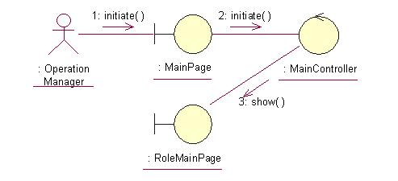
The above collaboration diagram shows the process flow after the actor has login.
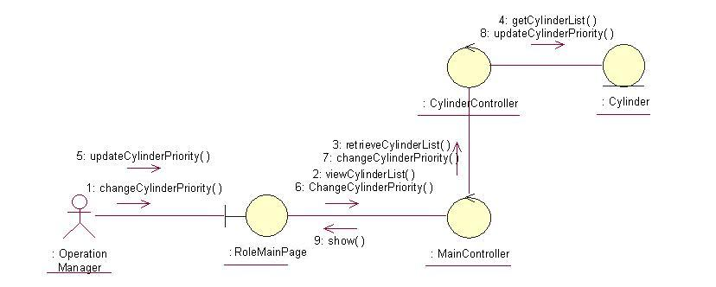
The above collaboration diagram shows the main process flow of this use case.

Participating Objects

Operation Manager
This actor represents the operation manager who will have a web page console to monitor and update the cylinder manufacturing operation.

Main Page
This object renders the contents after the actor has login. The Director, Department Manager and Operation Manager actors use this object.

Role Main Page
This object renders the contents (based on the user role) after the actor has login. The Director, Department Manager and Operation Manager actors use this object.

Main Controller
This object acts as the middleman between Main Page and the Cylinder Controller. It will translate interactions with the view into actions to be performed by the Cylinder Controller.

Cylinder Controller
This object acts as the middleman between “Change Cylinder Priority” Page and the Cylinder object. It will translate interactions with the view into actions to be performed by the Cylinder object.

Cylinder
This object stores the details concerning the cylinder information of the COMS.

Class Diagrams

Domain Class Diagram: Change Cylinder Priority

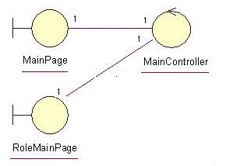
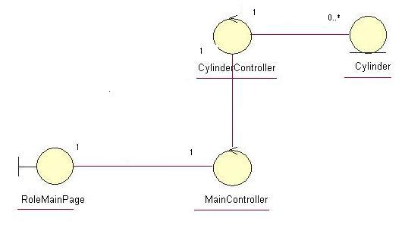

Derived Requirements
The Operation Manager PC keyboard and mouse will be used to enter Schedule details (if any) and view all the system responses.

